**END SEM REPORT**

**on**

**Visualization of Linear and Non-Linear Data Structure Using OpenGL**

**Submitted by**

Aman Sharma (Enroll No. R110218018)

Gaurvendra Singh (Enroll. No. R110218056)

Divyanshu Pande (Enroll. No. R110218054)

**Under the guidance of**

Ms. Ambika Aggarwal

**Assistant Professor (SG)**

**Department of Virtualization**



**SCHOOL OF COMPUTER SCIENCE**

UNIVERSITY OF PETROLEUM & ENERGY STUDIES

Bidholi Campus, Energy Acres, Dehradun – 248007.

**Aug- Dec (2020)**

 **School of Computer Science**

**University of Petroleum & Energy Studies, Dehradun**

**Project Proposal Approval Form (2020)**

I

**Minor**

**PROJECT TITLE:**  Visualization of linear and non-linear data structure using OpenGL.

**ABSTRACT:**

This project was inspired by this pandemic situation and online teaching mode, so we are creating a GUI based application to visualize linear and non-linear data structure. Plenty of learners and experienced developers abstain from learning Data Structures and Algorithms since it's convoluted what's more, they feel that there is no utilization of all the above stuff, in real life. Data structures and algorithms plays a significant role in implementing software and optimizing it. Knowledge of Data structures like Linked List, Trees, Graphs, and different algorithms go far in taking care of the issues productively and the interviewers are keener on perceiving how up-and-comers utilize these instruments to tackle an issue. Just like a car mechanic needs the correct device to fix a vehicle and make it run appropriately, a software engineer needs the correct device (Data structures and algorithms) to make the product run appropriately. So, to understand them efficiently and without any mistake, we need to visualize them.

**KEYWORDS:** DATA STRUCTURES, TREES, GRAPH, ALGORITHMS, LINKED LIST.

**INTRODUCTION:**

In this project, we shall visualize the linear and non-linear data structure using OpenGl A.P.I. We will use the C++ programming language to implement data structures part and various functions and we will useOpenGL Utility Toolkit (GLUT: a window system independent toolkit for writing OpenGL programs) for making the GUI. The Data structures that we will implement are:

* **Linear: -** Linked List (with all functions).
* **Non-Linear: -** Binary Search Tree (with all functions and traversals).

All the functions like insertion, deletion, etc. will take input value from the user and the user will have the option to select the data structure.

**CLASS DIAGRAM:**

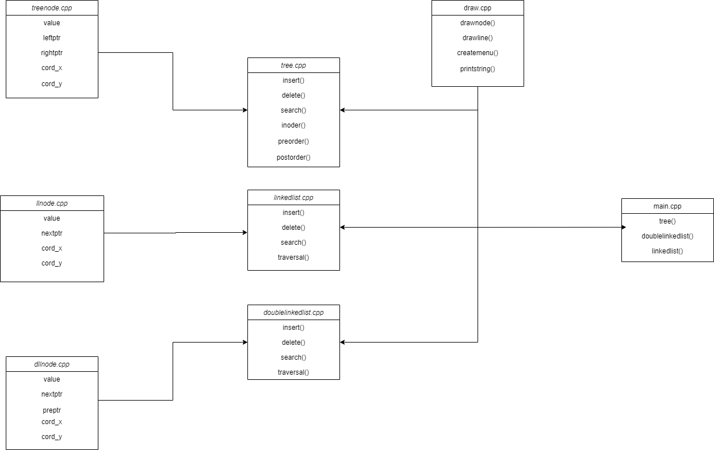

**PROBLEM STATEMENT:**

Visualization of linear and non-linear data structure.

**OBJECTIVES:**

To create a GUI based application that visualizes the data structures.

* **Sub Objectives:**
* Creation and visualization of Linked List.
* Creation and visualization of Binary Search Trees.
* Deleting nodes and Inserting nodes.
* Traversal of the data structure.

**METHODOLOGY:**

We have created a program in which the user will be given a menu in which he/she will have the option to select the data structure to visualize. After this, a window will open where the user will have the option to insert, delete, and traverse the data structure. Users will also have the option to exit the program.

The entire implementation of this project can be summarized in the following steps:

1. Taking the input from the user for data structure selection from a user-defined menu.
2. After this, the user will be directed to a GUI window with various options.
3. Then taking input values for the functions like the insertion of nodes, deletion of nodes, and the traversal on a GUI based window.
4. After performing the function, the data structure will be visible in the GUI window in an understandable format.
5. After this user can again perform the function or can exit the program.

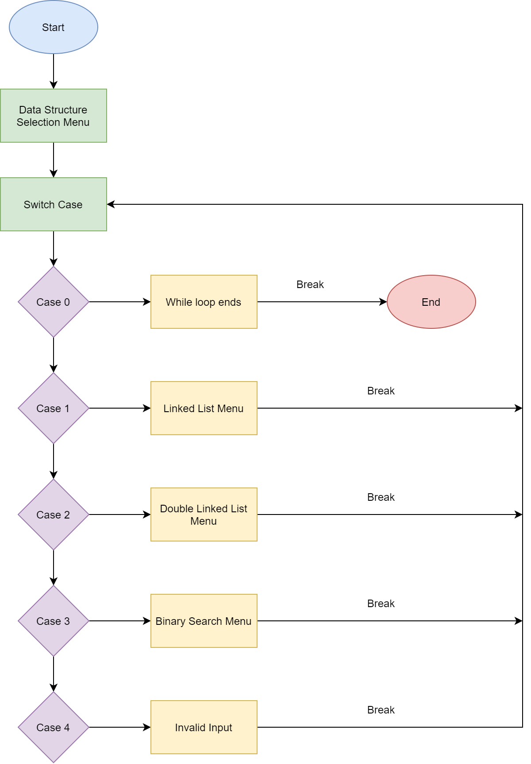

**SYSTEM REQUIREMENTS:**

* **Hardware:**
* RAM: 4GiB
* Disk Space: 1GiB (min)
* **Software:**
* Visual Studios
* **Operating System:**
* LINUX/WINDOW/OS X
* **Resources:**
* OpenGL API

**LITERATURE REVIEW:**

Here is the conclusion of some of the reference paper and the links that we review to make our project better and to know more technologies that we can use in our system:

* Using [3], we learned about different data structures, the uses, and various functions, and how to write the code efficiently. In [2] we learned about advance concepts of C/C++ programming like containers.
* OpenGL (GLUT) is very hard to understand. [1] provides a very easy to understand approach for implementing GLUT functions and [4] provides various concepts and ideas to implement various visualization tasks.
* Mathematics behind visualization is difficult. The paper [5] Highlights the idea of using vector and coordinates system to give the accurate position of the node after performing various functions.

**SCHEDULE (PERT Chart):**

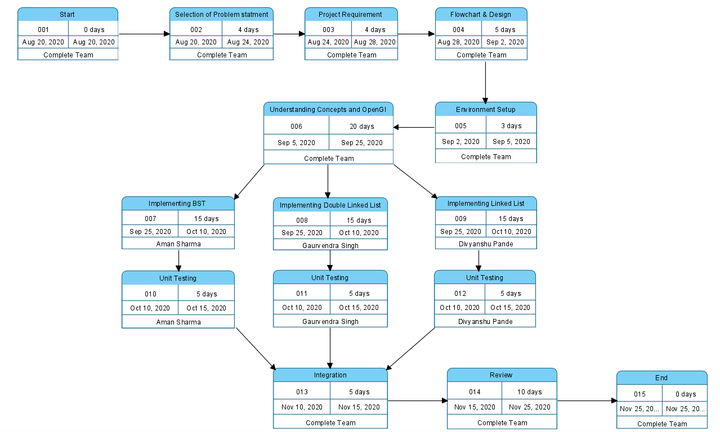

**Implementation:**

Here is the Implementation of our project.

* This is the snapshot of the interface of the main menu where we can select the data structure to visualize.

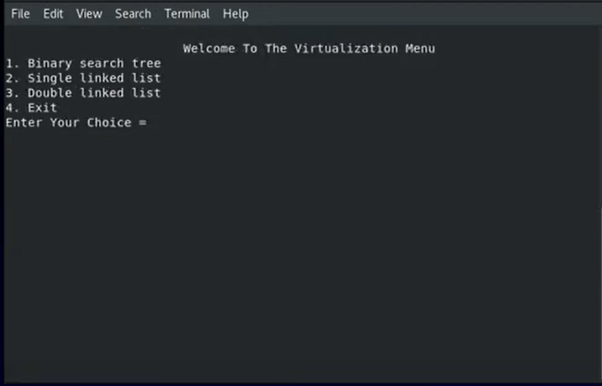

* This is the snapshot of the interface of Binary Search Tree interface where we can perform various functions using right click function menu.

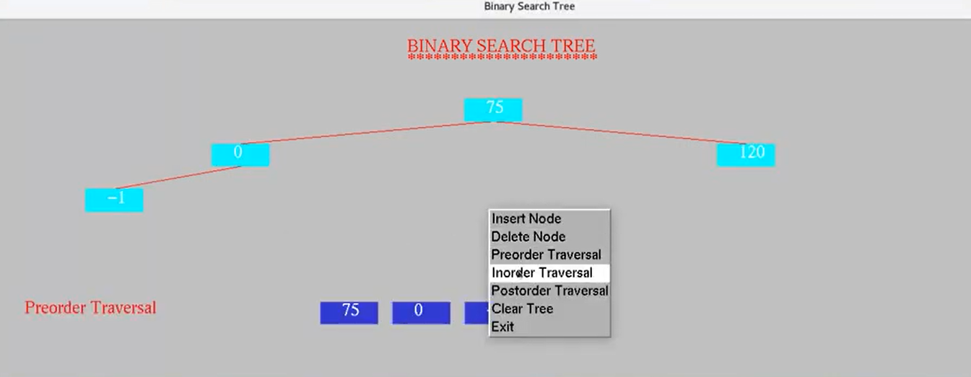

* This is the snapshot of the interface of Double Linked List interface where we can perform various functions using right click function menu.

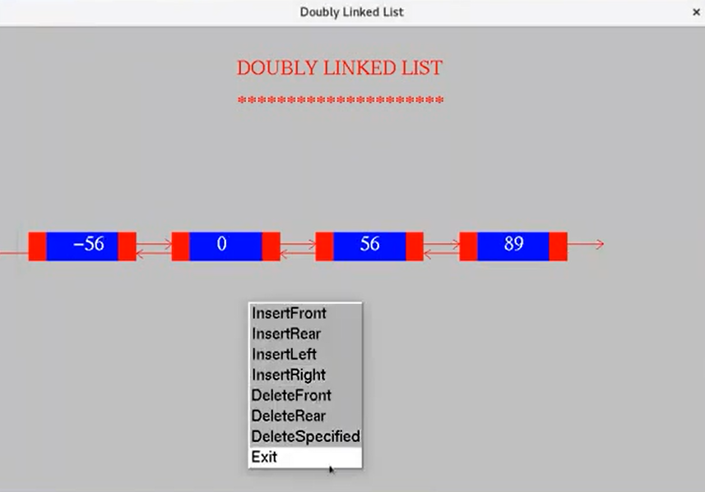

* This is the snapshot of the interface of Double Linked List interface where we can perform various functions using right click function menu.

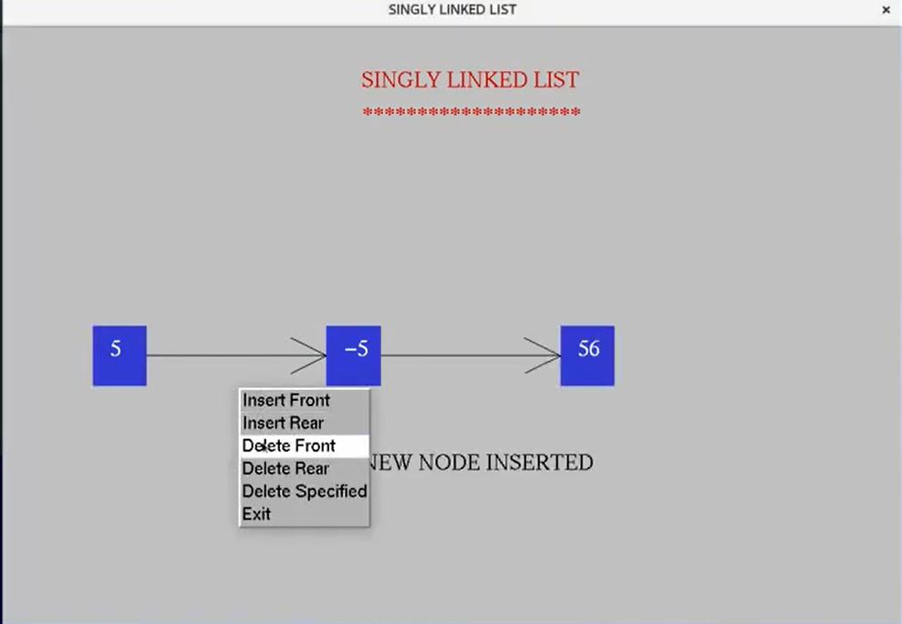

**REFERENCES:**

1. <https://www.opengl.org/resources/libraries/glut/spec3/spec3.html>
2. <https://en.cppreference.com/w/>
3. <https://www.geeksforgeeks.org/data-structures/>
4. <http://www.lighthouse3d.com/tutorials/glut-tutorial/>
5. https://www.researchgate.net/publication/338427156_Visualization_Research_of_STL_Model_Based_on_OpenGL_Technology

**Synopsis Draft verified by**

**Ms. Ambika Aggarwal Dr. Deepshikha Bhargava**

**(H.O.D.)**

**(PROJECT GUIDE) (Department of Virtualization)**